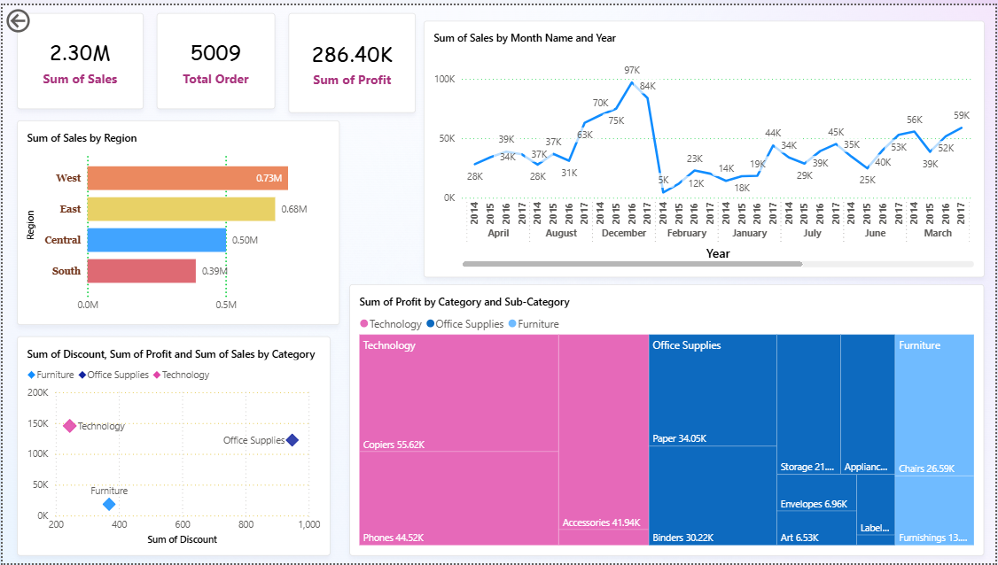

**📊 Insights & Recommendations**

**🔹 Key Insights**

1. **Regional Performance**
   * West region has the highest sales (0.73M).
   * South region contributes the least (0.39M).
2. **Category-Level Insights**
   * **Technology** is the most profitable category, especially Copiers (55.6K) and Phones (44.5K).
   * **Furniture** has the lowest profit despite high sales, mainly due to higher discounts.
   * **Office Supplies** generates steady profit with items like Paper (34K) and Binders (30K).
3. **Sales Trend**
   * Sales grew steadily from 2014 to 2017, peaking at 97K in December 2017.
   * Seasonal spikes suggest higher sales during year-end months (Nov–Dec).
4. **Discount Impact**
   * Higher discounts in Furniture are reducing profitability.
   * Technology shows better profit even with moderate discounts.

**🔹 Recommendations**

1. **Focus on Technology** products in marketing & promotions, since they deliver the highest profit margins.
2. **Optimize Furniture discounts** → reduce unnecessary discounts to improve profit margins.
3. **Region-Specific Strategy**:
   * Expand efforts in South region (low sales) to balance growth.
   * Leverage West region (high sales) for cross-selling opportunities.
4. **Seasonal Promotions**: Plan inventory & campaigns around peak months (Nov–Dec) to maximize revenue.